Student role: Moderator
Support in a course with continuous assessment with BigBlueButton

The situation:
A “hybrid scenario” refers to a teaching-learning situation in which some of the students take part on site in the course room while the remaining students either participate online or alternately continue working asynchronously.

Your role:
You are the moderator during the contact hour. Your task is therefore to support the teacher. This means giving students participating online at the same time the opportunity to join in. You are the ‘mouthpiece’ for students taking part online who contribute via the chat. This task will remain the same even when the entire course takes place digitally.

Preparation:
- Provided you have a laptop or other mobile device - with which you can enter Moodle - you will be asked to use it for moderation. Bring your laptop and a headset / headphones to the course or have them ready, should you also be present online yourself.
- It is recommended that you come to the course a few minutes earlier, or enter BigBlueButton earlier, in order to agree on the procedure with the teacher.
- Give the course participants the rights the teacher wishes them to have (see ‘Implementation in BigBlueButton’ on the next page).

Your tasks:
- Pass on questions and contributions to the teacher:
  - Monitor the chat: participants can post questions and contributions in the public chat.
  - Monitor the ‘status’ of the participants: this is shown in the participants’ name icon on the left-hand side. This can be changed by clicking on it and showing, for example, a raised hand. Participants who do so will be moved up in the view of all participants. Pay attention to this and draw the teacher’s attention to the fact that there are contributions or questions from students.
- Remind students participating online generally to switch off their microphone and only turn it on for speaking. This avoids disturbing background noise. As a moderator, you can also mute or unmute the microphone (see for this ‘Moderator's rights’ and instructions).

Moderator’s rights:
You are given the role of moderator in the video conferencing tool BigBlueButton for the course unit.
As moderator you have the following rights:
- activate participants
- activate microphone
- turn spectators into moderators or presenters
- downgrade moderators to viewers
- mute participants
- make yourself a presenter

Implementation in BigBlueButton:
Manage participants’ rights:
- Click on the gear symbol to the left of the screen (1).
- You can grant certain rights to participants in the course by selecting the menu item Lock viewers (2).
- At the beginning of the course, set the slider at Share microphone to green (3). Otherwise, participants will not be able to switch on their microphone when they want to talk to you or others. Then click on Apply (4).

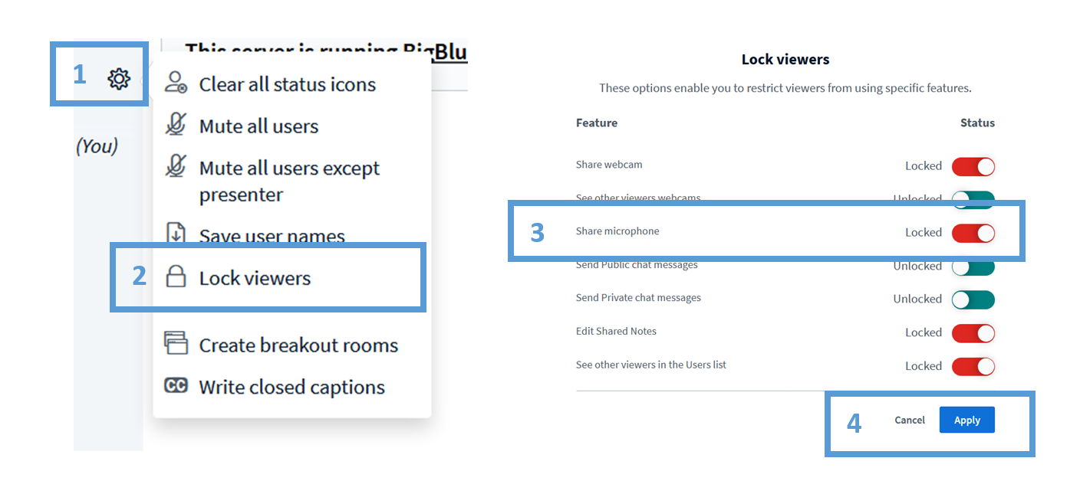

Make yourself a moderator: click on the + button and select ‘Become a presenter’:

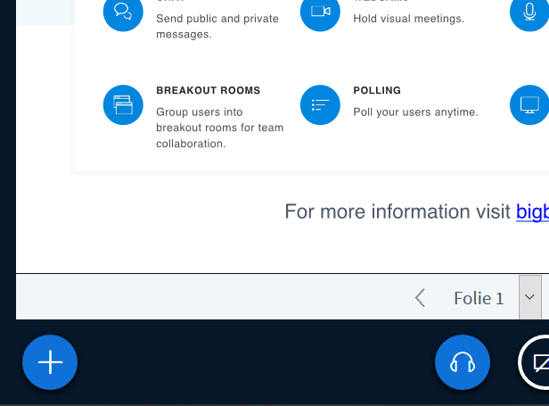

You can tell that you are now a presenter by the small blue icon next to your name:

As a presenter you can now share your screen, upload a PowerPoint presentation, show a video or create a survey. To do this, click on the + button again.
