Student role: Moderator
Support in a course with continuous assessment with Collaborate

The situation:
A “hybrid scenario” refers to a teaching-learning situation in which some of the students take part on site in the course room while the remaining students either participate online or alternately continue working asynchronously.

Your role:
You are the moderator during the contact hour. Your task is therefore to support the teacher. This means giving students who participate online at the same time the opportunity to join in. You are the ‘mouthpiece’ for students taking part online who contribute via the chat. This task will remain the same even when the entire course takes place digitally.

Preparation:
- Provided you have a laptop or other mobile device – with which you can enter Moodle – you will be asked to use it for moderation. Bring your laptop and a headset/headphones to the course or have them ready, should you also be present online yourself.
- It is recommended that you come to the course a few minutes earlier, or enter Collaborate earlier, in order to agree on the procedure with the teacher.
- Give the course participants the rights the teacher wishes them to have (see ‘Implementation in Collaborate’ on the next page).

Your tasks:
- Pass on questions and contributions to the teacher:
  - Monitor the chat: participants can post questions and contributions in the public chat ‘Alle’.
  - Monitor the ‘status’ of the participants: by clicking on their profile picture or the icon on the far left of the bar (see screenshots on the next page), participants can change their status and provide quick feedback.
  - Observe if participants raise their hand: by clicking on the small person with raised hand, students can raise their hand. Pay attention and alert the teacher that there are contributions or questions from students.
- Remind students participating online generally to switch off their microphone and only turn it on for speaking. This avoids disturbing background noise. As a moderator, you can also mute or unmute the microphone (see for this ‘Moderator's rights’ and instructions).

Moderator’s rights:
You are given the role of moderator in the video conferencing tool Collaborate for the course unit.
As moderator you have the following rights:
- activate microphone
- activate video
- turn spectators into moderators
- mute participants
- Share files, share content, create surveys

Implementation in Collaborate:
Status of participants and raising hands:
As moderator, you are shown whether and how many people are currently raising their hand:
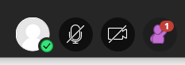

By clicking on the profile icon, participants can give immediate feedback. You as moderator will also see this:
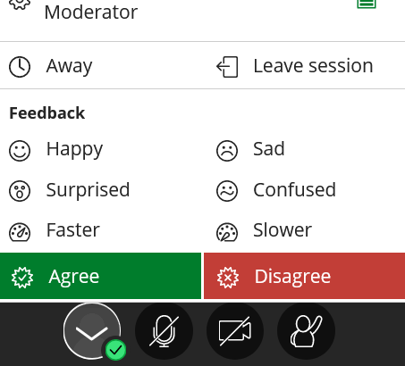
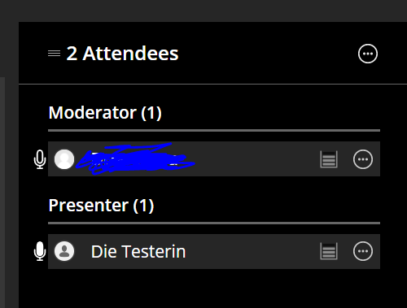

Manage participants’ rights:
The purple arrow sign leads you to the Collaborate area, where you can change settings as a moderator. Now click on the gear symbol. You can give certain rights to the course participants with the button Session Settings. At the beginning of the course, check Share Audio. Otherwise, participants will not be able to switch on their microphone when they want to talk to you or others.

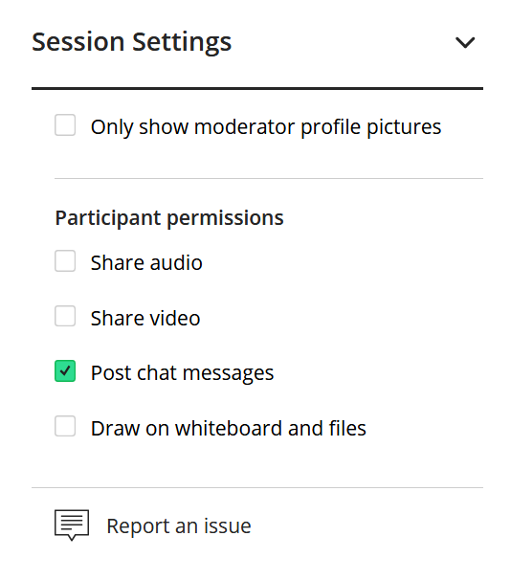

Share content:
Click on the purple arrow in the corner and then on the icon in the middle. Here you can share content, create surveys and form workgroups.

